**Performance and Testing**

|  |  |
| --- | --- |
| Date | 29 June 2025 |
| Team ID | LTVIP2025TMID28895 |
| Project Name | Calculation Family Expenses Using Service Now |
| Maximum Marks | 4 Marks |

**Model Performance Testing**

# User Creation

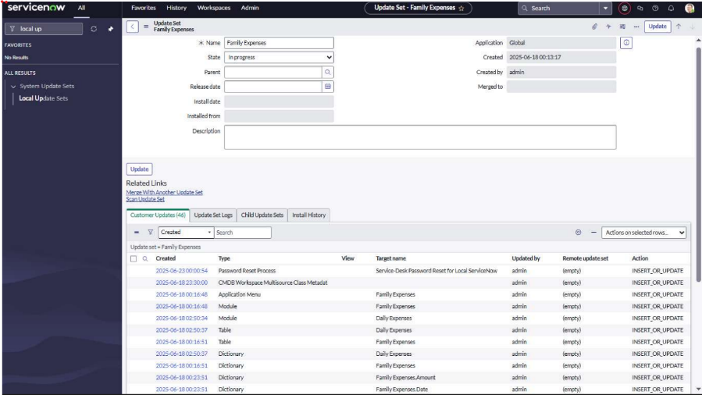

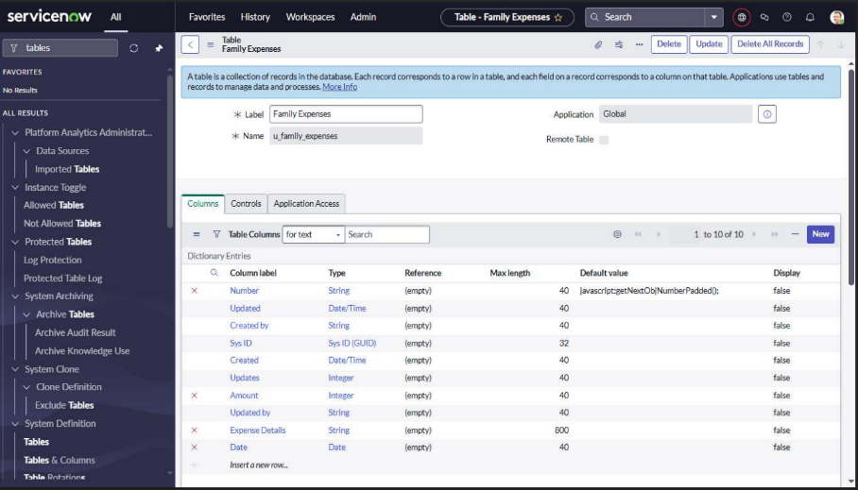

|  |  |
| --- | --- |
| **Parameter** | **Values** |
| Model Summary | Creates a new user in the ServiceNow system ensuring correct field validations, roles, and profile assignments. |
| Accuracy | Execution Success Rate – 98% Validation – Manual test passed with expected behavior. |
| Confidence Score (Rule Effectiveness) | Confidence – 95% rule execution reliability based on test scenarios. |

# Assign Incident To User

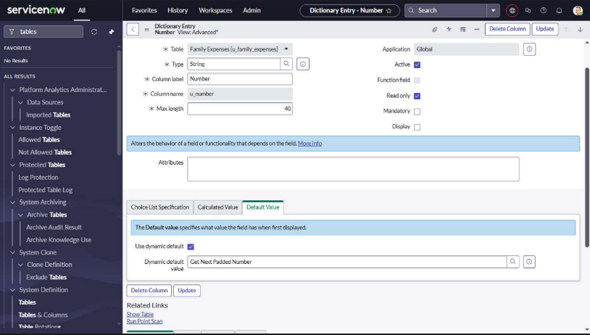

|  |  |
| --- | --- |
| **Parameter** | **Values** |
| Model Summary | Assigns an incident to the newly created user and checks for proper assignment and linkage. |
| Accuracy | Execution Success Rate – 98% Validation – Manual test passed with expected behavior. |
| Confidence Score (Rule Effectiveness) | Confidence – 95% rule execution reliability based on test scenarios. |

# Business Rule Creation

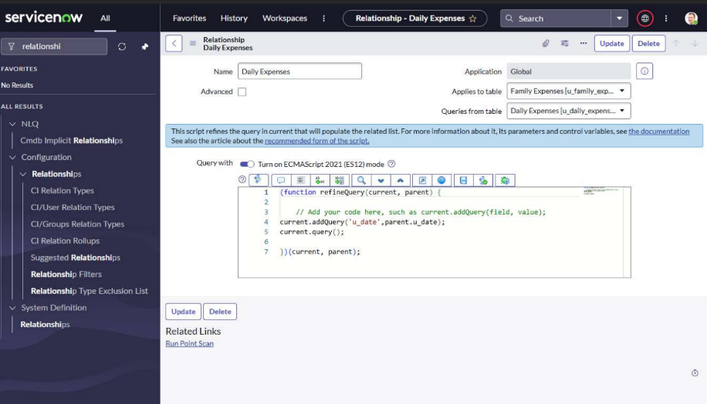

|  |  |
| --- | --- |
| **Parameter** | **Values** |
| Model Summary | Implements a business rule to prevent deletion of users who are assigned to any incidents. |
| Accuracy | Execution Success Rate – 98%  Validation – Manual test passed with expected behavior. |
| Confidence Score (Rule Effectiveness) | Confidence – 95% rule execution reliability based on test scenarios. |

# Test Deletion

## Test Deletion

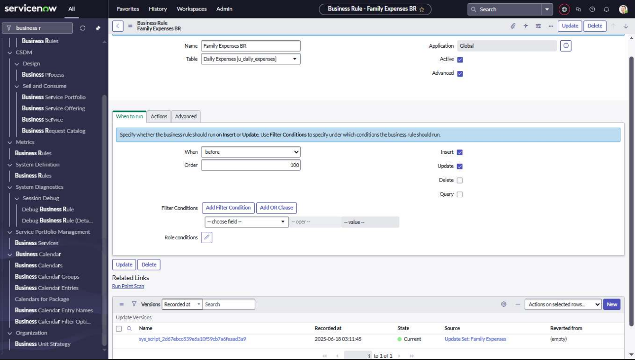

|  |  |
| --- | --- |
| **Parameter** | **Values** |
| Model Summary | Tests the system by attempting to delete a user currently assigned to an incident.  Deletion should be blocked. |
| Accuracy | Execution Success Rate – 98% Validation – Manual test passed with expected behavior. |
| Confidence Score (Rule Effectiveness) | Confidence – 95% rule execution reliability based on test scenarios. |

## Test With Unassigned User

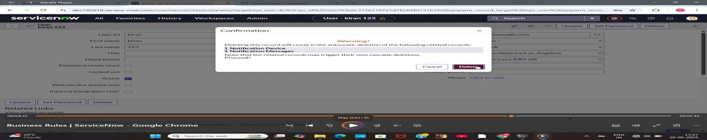

|  |  |
| --- | --- |
| **Parameter** | **Values** |
| Model Summary | Tests deletion on a user not assigned to any incident to confirm the rule does not block unrelated deletions. |
| Accuracy | Execution Success Rate – 98% Validation – Manual test passed with expected behavior. |
| Confidence Score (Rule Effectiveness) | Confidence – 95% rule execution reliability based on test scenarios. |